**Assignment – 9 A Job Ready Bootcamp in C++, DSA and IOT**

Switch Case Problems

**1. Write a program which takes the month number as an input and display number of days in that month.**

#include<stdio.h>

int main()

{

int m;

printf("Enter Month ");

scanf("%d",&m);

switch(m)

{

case 1:

case 3:

case 5:

case 7:

case 8:

case 10:

case 12:

printf("31 days");

break;

case 4:

case 6:

case 9:

case 11:

printf("30 days");

break;

case 2:

printf("28/29 days");

break;

default:

printf("Invalid choice");

break;

}

return 0;

}

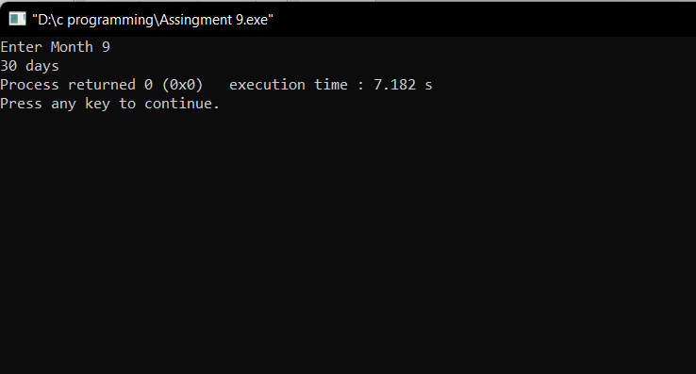

**2. Write a menu driven program with the following options:**

**a. Addition**

**b. Subtraction**

**c. Multiplication**

**d. Division**

**e. Exit**

#include<stdio.h>

int main()

{

float x,y;

int Choice;

printf("Enter two numbers ");

scanf("%f %f",&x,&y);

printf("\nEnter your Choice\n1.Addition\n2.Subtraction\n3.Multiplication\n4.Divison\n5.Exit\n\n");

scanf("%d",&Choice);

switch(Choice)

{

case 1:

printf("Sum of %f and %f is %f",x,y,x+y);

break;

case 2:

printf("Difference of %f and %f is %f",x,y,x-y);

break;

case 3:

printf("Product of %f and %f is %f",x,y,x*y);

break;

case 4:

printf("The Division of %f and %f is %f",x,y,x/y);

break;

case 5:

break;

default:

printf("Input valid choice");

break;

}

return 0;

}

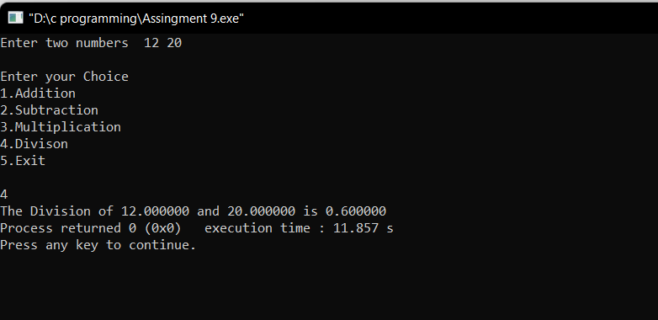

**3. Write a program which takes the day number of a week and displays a**

**unique greeting message for the day.**

#include<stdio.h>

int main()

{

int n;

printf("Enter a Number \n");

scanf("%d",&n);

switch(n)

{

case 1:

printf("MONDAY are for fresh starts.");

break;

case 2:

printf("TUESDAY If yesterday was not fine, today will be good and the coming day will be great.");

break;

case 3:

printf("WEDNESDAY Continue to smile.");

break;

case 4:

printf("THRUSDAY Always take failure as a challenge.");

break;

case 5:

printf("FRIDAY No matter what the day is, I hope you feel worth living every day.");

break;

case 6:

printf("SATURDAY is full of happiness and joy.");

break;

case 7:

printf("SUNDAY your bed is calling you to enjoy with me.");

break;

default:

printf("Input valid choice");

break;

}

return 0;

}

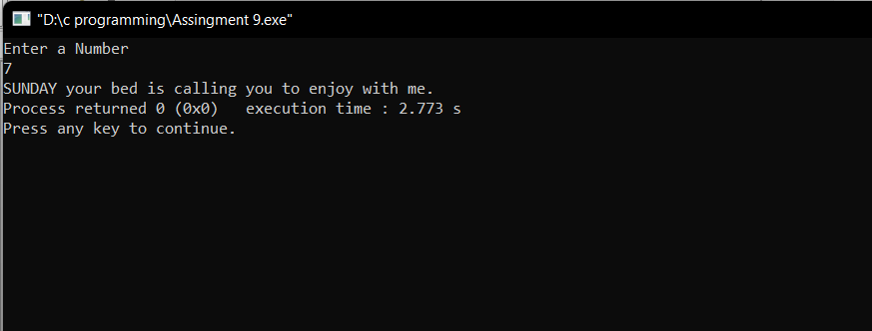

**4. Write a menu driven program with the following options:**

**a. Check whether a given set of three numbers are lengths of an**

**isosceles triangle or not**

**b. Check whether a given set of three numbers are lengths of sides of**

**a right angled triangle or not**

**c. Check whether a given set of three numbers are equilateral triangle**

**or not**

**d. Exit**

#include<stdio.h>

int main()

{

int a,b,c,choice;

printf("Enter the sides of triangle\n");

scanf("%d%d%d",&a,&b,&c);

printf("Enter your choice\n1. Check whether a given set of three numbers are lengths of an isosceles triangle or not\n2. Check whether a given set of three numbers are lengths of sides of a right angled triangle or not\n3. Check whether a given set of three numbers are equilateral triangle or not\n4. Exit\n");

scanf("%d",&choice);

switch(choice)

{

case 1:

if(a==b||a==c||b==c)

printf("Isosceles Triangle");

else

printf("Not a Isosceles Triangle");

break;

case 2:

if((a*a)+(b*b)==(c*c)|| (b*b)+(c*c)==(a*a) || (c*c)+(a*a)==(b*b))

printf("Right angled Triangle");

else

printf("Not Right angled Triangle");

break;

case 3:

if(a==b && c==a)

printf("Equilateral Triangle");

else

printf("Not Equilateral Triangle");

break;

case 4:

break;

default:

printf("Input valid choice");

break;

}

return 0;

}

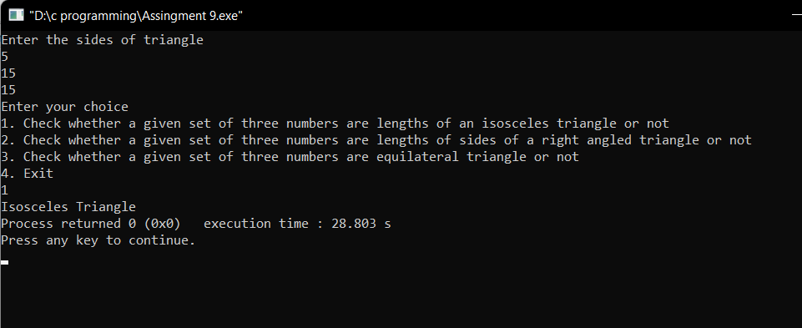

**5. Convert the following if-else-if construct into switch case:**

**if(var == 1)**

**System.out.println("good");**

**else if(var == 2)**

**System.out.println("better");**

**else if(var == 3)**

**System.out.println("best");**

**else**

**System.out.println("invalid");**

#include<stdio.h>

int main()

{

int var;

printf("Enter your choice\n");

scanf("%d",&var);

switch(var)

{

case 1:

if(var==1)

printf("good");

break;

case 2:

if(var==2)

printf("better");

break;

case 3:

if(var==3)

printf("best");

break;

default:

printf("invalid");

break;

}

return 0;

}

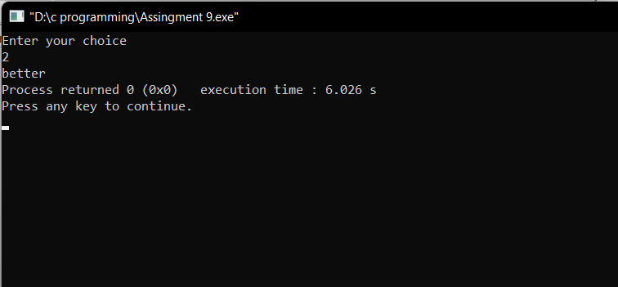

**6. Program to check whether a year is a leap year or not. Using switch**

**Statement**

#include<stdio.h>

int main()

{

int year,y;

printf("Enter year\n");

scanf("%d",&year);

y = (year%400)==0 || (year%100==0) || (year%4==0);

switch(y)

{

case 1:

printf("%d is the leap year\n",year);

break;

case 0:

printf("%d is the not leap year\n",year);

break;

default:

printf("%d is the not leap year\n",year);

break;

}

return 0;

}

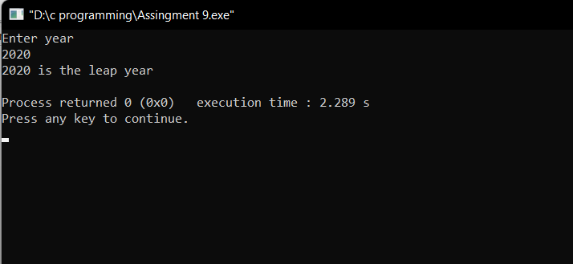

**7. Program to take the value from the user as input electricity unit charges**

**and calculate total electricity bill according to the given condition . Using**

**the switch statement.**

**For the first 50 units Rs. 0.50/unit**

**For the next 100 units Rs. 0.75/unit**

**For the next 100 units Rs. 1.20/unit**

**For units above 250 Rs. 1.50/unit**

**An additional surcharge of 20% is added to the bill.**

#include<stdio.h>

int main()

{

float unit,amount=0,finalbill=0;

printf("Enter electricty unit charges\n");

scanf("%f",&unit);

switch(unit<=50)

{

case 1: amount=unit*0.50;

break;

case 0: switch(unit<=150)

{

case 1: amount = 25 + (unit-50)*0.75;

break;

case 0: switch(unit<=250)

{

case 1: amount = 100+ (unit-150)*1.20;

break;

case 0: amount = 220 + (unit-250)*1.5;

break;

}

}

}

finalbill= amount + amount*0.20;

printf("Total amount = %f",finalbill);

return 0;

}

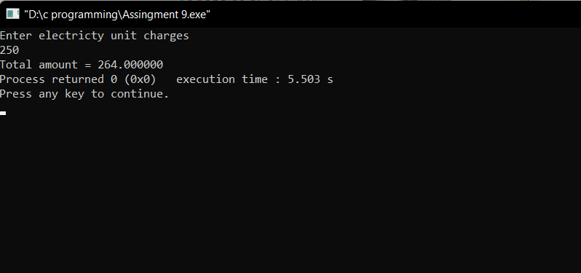

**8. Program to convert a positive number into a negative number and negative number into a positive number using a switch statement.**

#include<stdio.h>

int main()

{

int choice;

float num;

printf("1. convert a positive number into a negative number\n2. negative number into a positive number\n");

printf("\n\nEnter your choice\n");

scanf("%d",&choice);

switch(choice)

{

case 1:

printf("Enter a Positive number ");

scanf("%f",&num);

printf("The negative value of %f is %f",num,num*(-1));

break;

case 2:

printf("Enter a Negative number ");

scanf("%f",&num);

printf("The Positive value of %f is %f",num,num*(-1));

break;

default:

printf("invalid choice");

break;

}

return 0;

}

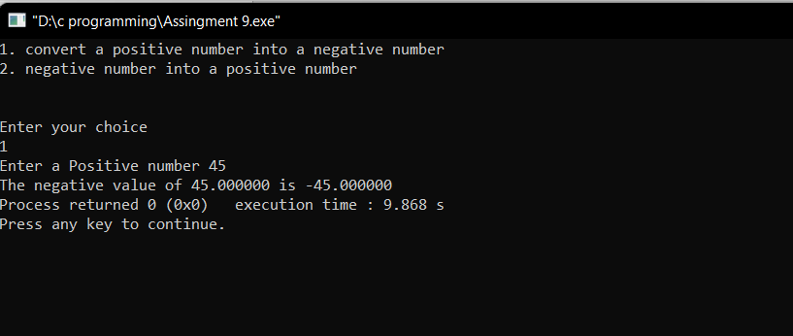

**9. Program to Convert even number into its upper nearest odd number**

**Switch Statement.**

#include<stdio.h>

int main()

{

int num;

printf("Enter a number\n");

scanf("%d",&num);

switch(num%2==0)

{

case 1:

printf("The upper nearest odd number of %d is %d",num,(num+1));

break;

case 0:

printf("The number you entered is odd");

break;

}

return 0;

}

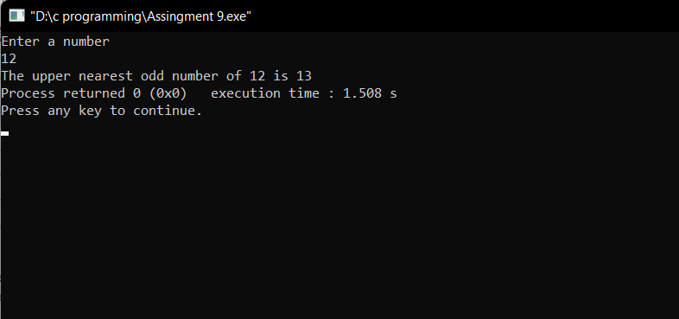

**10. C program to find all roots of a quadratic equation using switch case**

#include<stdio.h>

#include<math.h>

int main()

{

int a,b,c,D;

float x,y;

printf("Enter the coefficient of x^2, x and constant ");

scanf("%d %d %d",&a,&b,&c);

D=b*b-4*a*c;

switch(D>0)

{

case 1:

printf("Roots are real and distinct");

x=(-b+sqrt(D))/(2*a);

y=(-b-sqrt(D))/(2*a);

printf("\nRoots are %f , %f",x,y);

break;

}

switch(D<0)

{

case 1:

printf("Roots are imaginary");

break;

default :

printf("Roots are equals");

x=-b/(2.0*a);

printf("\nRoots are %f",x);

break;

}

return 0;

}

